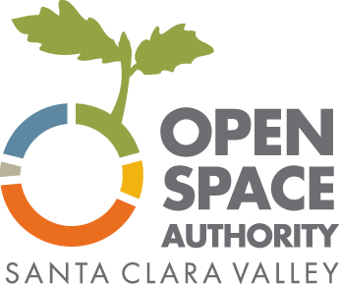
Open Space Authority Urban Grant Program 2020

ZoomGrants Tutorial

ZoomGrants is an online grant application tool used for the Grant Program. Below are instructions with screenshots to help you navigate the system.

Grant questions |  | Technical questions
Megan Dreger  Grants Administrator  Email: mdreger@openspaceauthority.org  Phone: 408-224-7476 |  | ZoomGrants Tech Support Desk  (7am - 4pm Monday - Friday)  Email: Questions@ZoomGrants.com  Phone: (866) 323-5404 x2  FAQ: https://zoomgrants.zendesk.com

General tips:
Preferred Browser: ZoomGrants can be used on any internet-enabled device using a recent version of any browser. ZoomGrants recommends using Chrome.

Text Entry: You are welcome to compose your answers in a word processor outside of the ZoomGrants application and then copy and paste your responses into the answer fields in the online version. However, please note that ZoomGrants fields will not save the formatting (bold, italics, bullets, etc).
ZoomGrants recommends using unformatted text only.
Auto-Save: ZoomGrants automatically saves your progress, so you can log out and log back in as many times as you need to in order to complete your Application. You do not need to complete your application in one sitting.

Accessing ZoomGrants
The Urban Grant Program application is available at: https://www.zoomgrants.com/gprop.asp?donorid=2232&rfpid=1894

It is also linked from the OSA’s web page http://www.openspaceauthority.org/urban.

ZoomGrants Sign In
The first time you use ZoomGrants, you’ll need to create a new account. Note that if awarded, this is the same account that will manage all required reports, payment requests, and other details.
If you already have an account, log in using the boxes for existing users at the upper right corner.

ZoomGrants Overview
The ZoomGrants page includes:
- Refresh Page Button: ZoomGrants auto-saves regularly for most text entries, but there is also a ‘Refresh Page’ button in case you do not see changes automatically update. Note that some pages (e.g. the Documents page for uploading files) require you to use the ‘Refresh Page’ in order to see your changes.

- Quick Access to the three Application tabs: Applicant Information, Project Description, and Documents Upload.
General Info
Quick Access to Application Pages

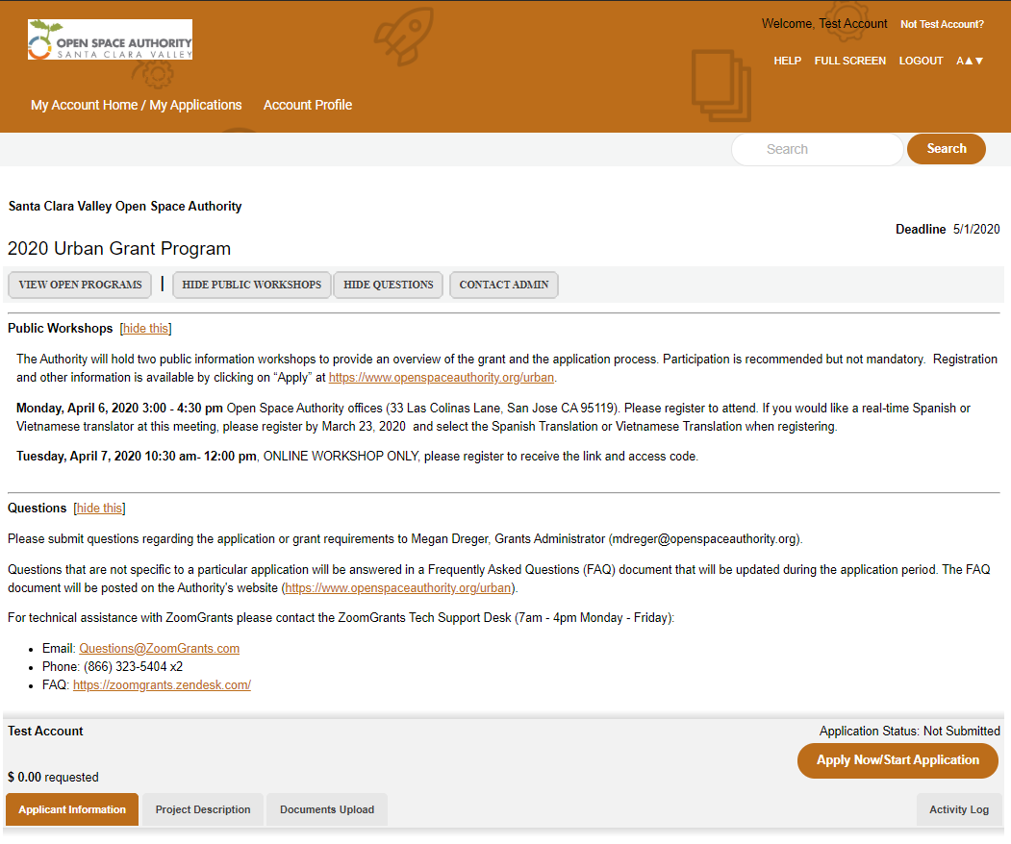

Applicant Information Tab
This page includes questions about the organization.
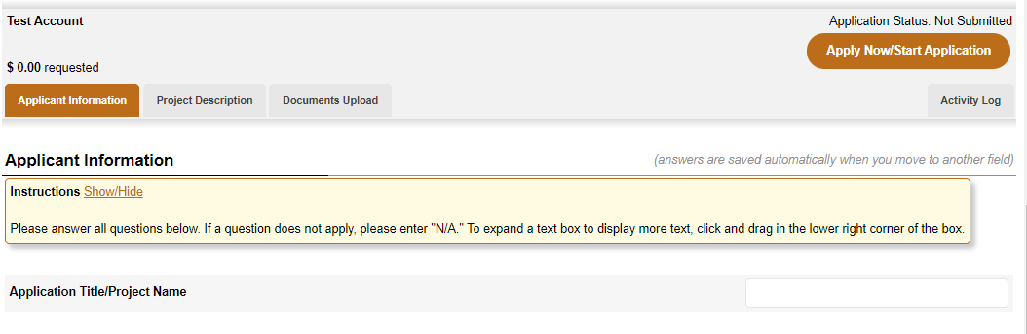

Applicant Information Tab - Adding Users to an Account
Each organization’s account is managed by one single login credentials (email address and password). If you’d like to allow others to access the account you can either:
- Share your login credentials
- Invite others by adding them as ‘Collaborators’. This section is near the top of the Applicant Information page. Add their email address and click ‘Invite’. They will receive an email invitation. Note: Collaborators can edit the answers to application questions, but they cannot submit, archive, or delete an application.

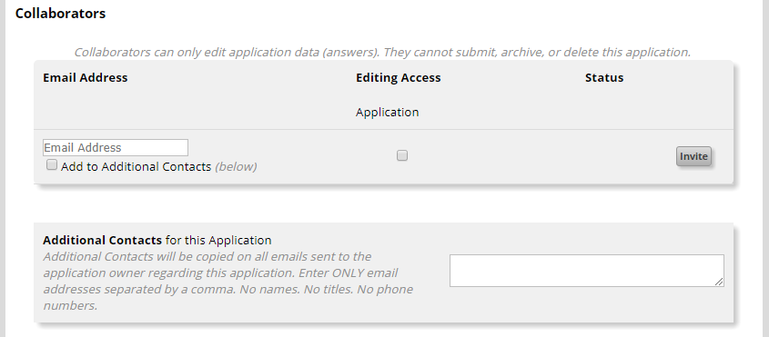

Project Description Tab
This page includes the application questions. Please answer all questions. If a question does not apply, please enter "N/A." Note that if any are left blank, ZoomGrants will not allow you to submit the application.
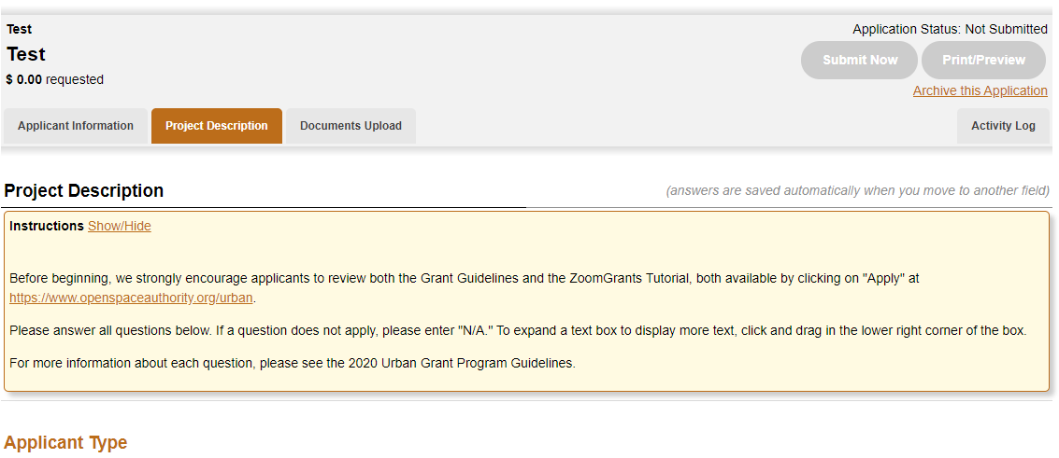

Documents Upload Tab
This form is to upload all required documents. All applications must upload a financial statement and a Project Budget. Other documents may be required, depending on the project. Note that the application cannot be submitted until at least the two required documents have been uploaded.
To upload a document:
- Download the template, if applicable. This template is required for the budget.
- Click on ‘Upload’
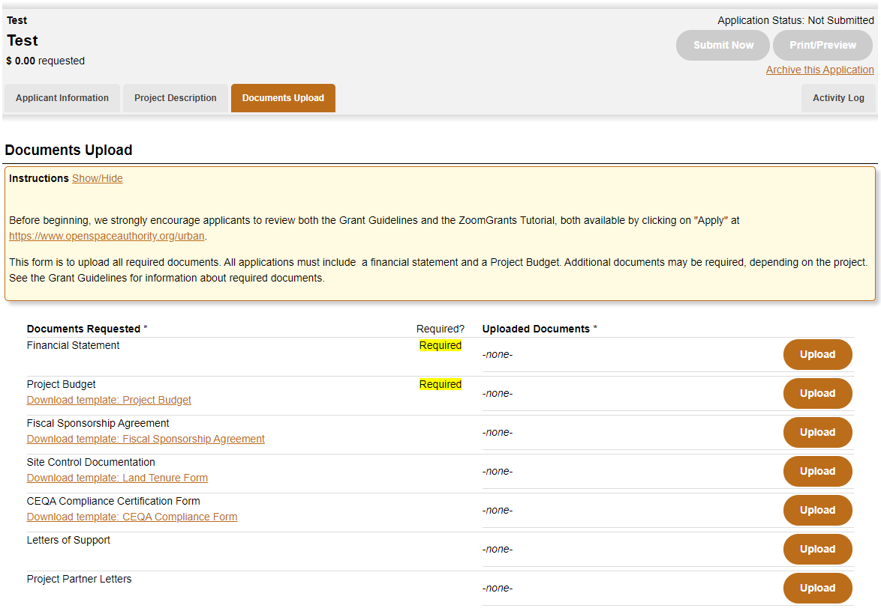

1. Template
2. Upload

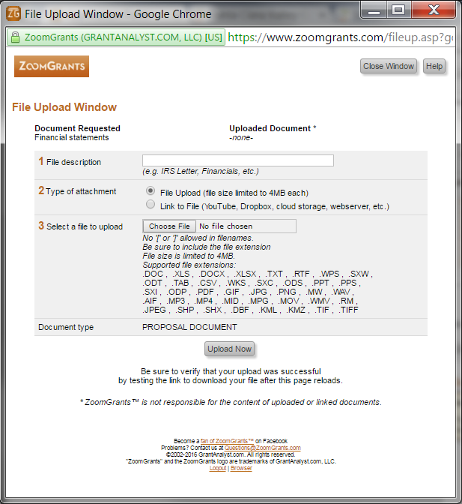
- A File Upload Window will appear. If it does not appear, it may be due to your browser’s popup blocker. Check your browser’s settings to enable popups for this website.

- Files can either be uploaded or linked. For files larger than 4 Mb, please use the link option. Multiple files can be uploaded to the same category (e.g. multiple files under Letters of Support).
3. File Upload

- Click on the ‘Refresh Page’ at the top of the Documents page to update the list of uploaded files.

Submitting the Application
Once you have answered all questions and uploaded the required documents, click on ‘Submit Now.’
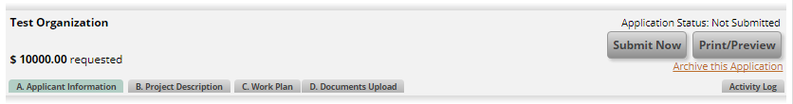

The system will check to ensure you have answered every question and uploaded the required documents. Any skipped questions or missing documents will be listed in red.
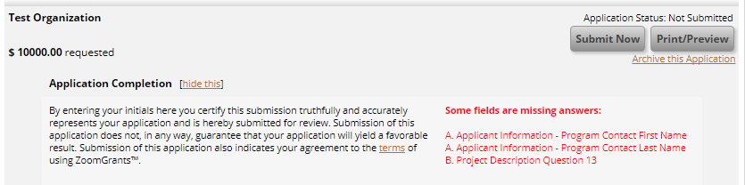

Once you’ve corrected any missing questions/documents, click the gray ‘Refresh Page’ button at the top of the page to refresh the submission errors. Click ‘Submit Now’ and you’ll see the Application Completion check. Add your initials and Click ‘Submit Now’
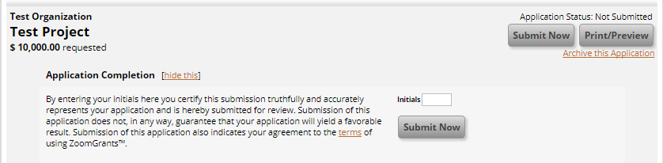

Success! You will see a note that the application has been submitted. An email confirmation will also be sent.
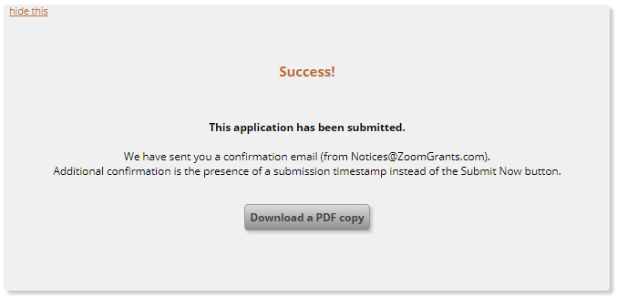

Accessing an Application in Progress
Once you’ve started an application, it will be saved and you can return any time before the deadline to continue working on it. To access an application, return to the ZoomGrants login page: https://www.zoomgrants.com/gprop.asp?donorid=2232&rfpid=1894
Click on the title of your application to edit. In this example, the title of the application was “Test Project”.
